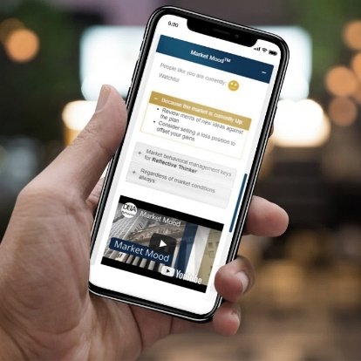
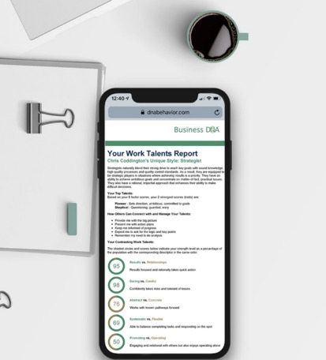
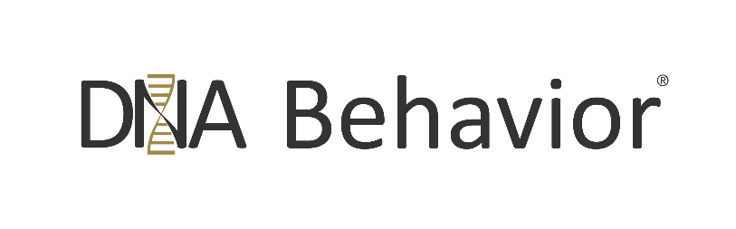
A Guide to the DNA Hiring Performance Process

Table of Contents

Introduction 3
Unpacking the Hiring Problem 3
Behavioral Variability Explained 4
Systemic Behavioral Biases 5
Random Noise 5
The Need for a Structured Hiring Process 6
Managing the Legal Risks 7
Select a Hiring Decision Moderator 8
Building a Structured Hiring Process 9
Provide Space for Cognitive Reflection 9
Select a Hiring Panel of Experts 10
Pre-Hiring Steps Checklist 11
Screening Candidates Process 12
On-Line and Telephone Interview Screening 12
Measuring Candidate Responses 13
Adopting a Structured Approach to the Interviews 13
Interview Meeting Principles 14
Assessing the Candidate’s Interview Performance 15
Second Interview 16
Third Interview 16
Cognitive Reflection Process Before Making the Final Decision 16
DNA Behavior Talent Assessment Checklist for the Recruiter 17
Leveraging a Decision-Making Digital Twin in Hiring 18
Make The Offer - Hiring the Successful Candidate 19
Post-Hiring Steps -Team Integration 19
Reference Materials for Hiring: 21
Appendix: Due Diligence for Hiring 22

DNA Hiring Performance Process
Introduction

A solid, robust behavioral based hiring process attracts suitable candidates. It engages the whole team as they need to trust the organization’s ability to consistently make quality recruiting and internal promotion decisions.
- Continual variability in the decision-making can unnerve the team and does not send the right message concerning the management of the inherent behavioral diversity in any organization.
- Further, there is a considerable cost to the organizations when variable decision-making behaviors of the hiring team are unknown, resulting in the wrong hire. The same issues exist for management teams responsible for promoting team members.

Given that the hiring decisions (for recruits or internal promotion) are human beings, there will inherently be a mix of different perspectives, biases, and random thinking being brought to bear on the decisions. Nevertheless, from the DNA Behavior perspective, the different decision-making styles of the hiring panel (and humans in general) can be revealed, measured, and managed.
Without understanding how the spontaneous deployment of intuition can lead to sub-optimal results, decision-making will always be flawed. Nevertheless, recognizing that decision-making will be improved if the practice of intuition is delayed until there has been an appropriate level of cognitive reflection will lead to significantly more effective hiring decisions and organizational decisions in general.
Over the years, much has been said about the substantial cost of a bad hire. Usually, hiring mistakes are blamed on the employee's performance, the manager, and other organizational or environmental issues.
However, these reasons for hiring mistakes do not satisfactorily explain why a medium to large organization hiring and promoting many people each year for similar roles can get it so consistently wrong.
The landscape is looking increasingly bleak in the hiring process, as reported in January 2020 by the Manpower Group. They released research in advance of the World Economic Forum in Davos that Global talent shortages had almost doubled in the last decade. 54% of companies reported skill shortages in 36 of 44 countries, finding it progressively more challenging to attract skilled talent than in 2018. Further, the number of vacant jobs worldwide is expected to exceed 85 million by 2030.
As the need to get hiring right the first time and reduce attrition, DNA Behavior has produced this guide to help you understand the root cause of hiring mistakes and to provide a structured hiring process that can be deployed for substantially overcoming the problem.
Unpacking the Hiring Problem

All across the world, something has shifted in the working world over the past two-plus years. Organizations are struggling to adjust to the change in how people want to work and their expectations; in other words, do I want to work for you?
There are several ways to approach recruiting. The first is internally through your designated departments, and another is using a recruitment agency, perhaps even job portals. The critical issue is to get the process right, find the right candidate for the job, and avoid costly attrition.
There are many moving parts to the hiring process, making it vulnerable at each stage to produce the right decision about a candidate. Regardless of your hiring approach, there are key issues to be considered.
Behavioral Variability Explained
Humans hire humans – that’s a given. Even using available tools, in the end, someone makes a decision. These decisions make the hiring process vulnerable if not understood and managed.
So, why do decision-makers with the same specific hiring task, including the same set of facts, circumstances, information, analytics, guidelines, or questions, respond and select differently from a group of candidates?
The problem is primarily "Behavioral Variability" caused by the imperfect makeup of the human mind. Research shows that when a person's intuition is not fully informed with independent data produced by experts, it is only 28% accurate. After interviewing the same candidate, there can be a correlation of 62% to 65% between the hiring panel members which is a 35% to 38% variability in hiring performance.
DNA Behavior uses the all-encompassing term “Behavioral Variability” to address the imperfection of human decision-making and how it is reflected by different individuals making decisions about similar transactions or events. Hiring and promoting people is an area where Behavioral Variability regularly occurs.
The impact of human Behavioral Variability is often experienced at a substantial level when:
- Different decision-makers make intuitive judgments concerning similar hiring decisions regularly required within the business without (a) appropriately set benchmarks and (b) understandable guidelines.
- When groups make complex hiring decisions for one-off positions (e.g., a Board or a team) without a structured process to (a) reduce prejudgments, (b) address false or inadequate information, and (c) align an appropriate balance of risk and reward.

The variable behavioral influences and factors impacting individual and group decision-making can be broken down into two core areas:
- Systematic Behavioral Biases; and
- Random Noise

The Biases and Noise in any decision are separately identifiable and measurable errors, although they nevertheless have a close relationship. Putting measurement on Behavioral Variability takes it from being an invisible energy force in the organization to a visible one. Research has shown Behavioral Variability to be more widespread than most leaders are aware of by five times.

Systemic Behavioral Biases:
Every human has a complex set of behavioral biases in the way they make decisions which, if not managed, lead to imperfect decision-making or what is perceived as being irrational decisions. In simple terms, human beings are not perfect in the processes they use in making decisions.
A behavioral bias is a systematic thought process caused by the tendency of the human brain to simplify information processing through a combination of two levels:
- An automatically built-in filter coming from the subconscious mind based on their DNA Natural Behavior Style which will repeatedly show up without the person realizing it, particularly under stress or pressure; and
- A learned filter based on more conscious personal experiences, preferences, and education. The conscious brain works eight seconds slower than the unconscious brain.

Systemic behavioral bias will show up in hiring when the decision-maker assesses candidates from their perspective or lens rather than what may be required for the position. So, they may have a natural leaning toward people similar to them. Behavioral Variability is then exposed by others consistently using their unique lens to make different decisions.
In many cases, the biases reveal themselves as rules-of-thumb (heuristics) that can be applied to guide decision-making based on a more limited subset of the available information. These behavioral biases rely on less information; they are assumed to facilitate faster decision-making than strategies requiring more information. However, they may not result in better hiring decision-making because the information relied upon is mistaken, incomplete, or inaccurate.
Nevertheless, while a behavioral bias is often considered a weakness or mistake, it can also become a strength in decision-making if understood and correctly channeled.
Random Noise
There will be random Noise – that is, variability in decisions that should be identical when individuals looking at the same issue or candidate without logical reason vary their responses depending on their different mindsets or moods. However, the most significant area of Noise causing the error is when people (such as hiring or promotion panels) look at the same candidate, and their responses differ hugely. Additionally, the individuals on the panel are unaware of this Behavioral Variability.
Most of the random Noise reflects the idiosyncratic reactions to a given candidate. However, Noise is also caused by random impressions formed in the informal rapport-building phase of interviews (first 2 or 3 minutes). So, first impressions count.
In addition, when a group, such as a hiring panel, is making a collective decision about a candidate then there will be additional random Noise that is likely to pollute the decision. It is likely the group will be swayed by early impressions of the candidate and what others on the hiring panel think. The factors causing group noise amplification are shown in the diagram below.
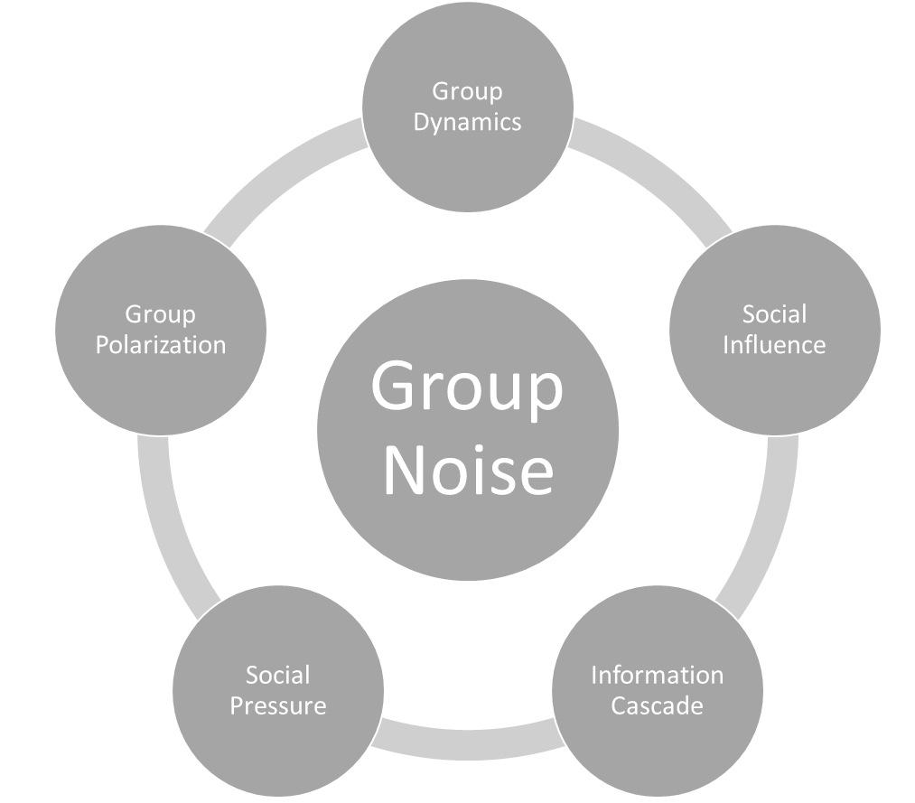
The Need for a Structured Hiring Process
Without a structured hiring process designed to overcome Behavioral Variability the following typically happens:

There is a failure to follow consistent hiring processes for every candidate.
- Decisions are made based on objective ignorance being unrevealed facts the recruiter could not possibly know, which may impact a candidate's performance.

Judgment calls are made about the candidate based on the individual recruiter’s pre-conceived thinking, perceptions, biases, money attitudes, and emotions.
- Physical appearance influences the questions the interviewer asks, consequently failing to add depth to the questioning.
- The intuition of the recruiter is not powered adequately with sufficient independent information to make a fully informed decision.
- The ego of the recruiter gets in the way of the process with over-confidence in their ability to assess candidates.
- The recruiter may exhibit a conclusion bias through bypassing evidence or observations to fit a need.
- The recruiters fail to understand and use behavioral instruments and established benchmarks most relevant to the hiring decision.
- Each recruiter’s own behavioral style and psychological mindset may be at play causing them to focus on various aspects of the candidate. Further, the interviewers may steer the interview because of their biases and perceptions.
- The recruiter does not have the knowledge, skills, and (particularly) experience necessary to have developed an expert perspective and a more highly-tuned intuition.

Inconsistencies occur in interviewing techniques and questioning, including a lack of depth in the interviewing process in the right areas. For instance, understanding the candidate’s true character, identity, passions, values and even their money attitudes.
- A dominant individual overly influences the hiring team's decisions.
- Too much weight will be given to the discussion and too little to attributable data.

Managing the Legal Risks
Decision makers involved in candidate selection for either hiring or promotion who are not trained in interviewing techniques or do not have a clear understanding of Behavioral Variability open the door to allegations of discrimination.
In addition, in today’s world many organizations are using various forms of software programming and AI to assist with the hiring process. They should be mindful of the fact that algorithm bias can creep in because of the biases of the human’s programming the software and AI.

Therefore, organizations involved in hiring should be mindful of the Department of Justice (DOJ) recent guidance:

“Employers now have a wide variety of computer-based tools available to assist them in hiring workers, monitoring worker performance, determining pay or promotions, and establishing the terms and conditions of employment. Employers may utilize these tools in an attempt to save time and effort, increase objectivity, or decrease bias. However, the use of these tools may disadvantage job applicants and employees with disabilities. When this occurs, employers may risk violating federal Equal Employment Opportunity (“EEO”) laws that protect individuals with disabilities.”

The DOJ focuses on the careless use of AI that could violate U.S. laws protecting equal access for people with disabilities. A carefully designed hiring process should lead to the proper management of diversity, equity, and inclusion (DEI). Complete guidance can be found in the Americans with Disabilities Act and the Use of Software, Algorithms, and Artificial Intelligence to Assess Job Applicants and Employees.
In certain regulated industries, criminal background checks are a part of the hiring process. This requirement extends to those serving vulnerable populations, such as children, the elderly, or the disabled. Employers should seek guidance from their appropriate regulatory body, such as the Equal Employment Opportunity Commission or the Federal Trade Commission.

Select a Hiring Decision Moderator

Having set out the very real challenges facing the hiring process, regardless of whether using internal hiring departments, external recruiters, online portals, or some other approach, the most important key to successfully hiring candidates is to ensure there is consistency in the decision-making approach.
Author Mark Murphy founder of Leadership IQ surveyed 2,770 leaders and employees in the United States about their companies' hiring practices and worker shortage during the last quarter of 2021. Respondents answered more than two dozen questions about their organization's hiring practices and current levels of the worker shortage.
A subset of the study participants who identified as HR executives were asked to assess to what extent their company's hiring managers are consistent in how they interview candidates. As you can see in the chart below, there are serious inconsistencies across hiring managers in most organizations.
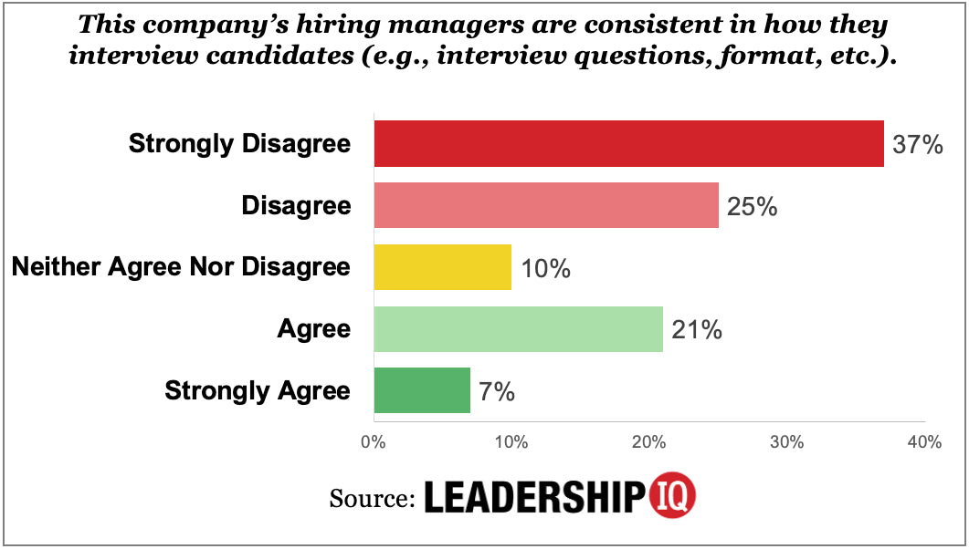
DNA Behavior believes the starting point to resolving the inconsistency issue is to use a Decision Moderator (DM). The function of the DM is to oversee the implementation of a consistent hiring process from start to finish to ensure the Behavioral Variability is mitigated. The role should be impartial. They should not be a voting member of the sifting, hiring, or final offer stage.
Their role would be as follows:
- Select and moderate the internal Hiring Panels, external Recruiters, and IT Portals.
- Provide the individual representatives involved in decision-making with oversight and understanding of the risks of Behavioral Variability and have them understand that at each step of their evaluation process, they complete the 1-5 process as highlighted in the section titled Select a Hiring Panel of Experts.
- Ensure that the correct processes are followed, including having the skills to mitigate the Behavioral Variability caused by Systematic Bias and Random Noise.
- Liaise between external recruiters, IT Portals, and the organization's C-Suite to ensure consistency in approach.

It is recommended that the DM is a person found in the Organization’s Behavioral Sciences or People Culture Division, should they have one or some other person in the organization capable of facilitating decision-making. Alternatively, they can be an external consultant who is retained for the DM role.

Therefore, the DM must be behaviorally trained, understand the Gene Decision Method for decision-making (refer below), and capable of overseeing the design of a Decision-Making Digital Twin for Hiring (refer below).

Building a Structured Hiring Process

At the outset, the organization needs to be very clear about its culture and who fits in that culture from a values perspective. The culture must ultimately reflect the organization’s desired identity internally but also externally with clients or customers and all stakeholders. The people hired into the organization and those promoted to step up and lead must reflect the culture. That requires the hiring practices to reflect the culture.
In considering the culture, for organizations to succeed in hiring talent in the new world they must recognize that most employees are not going to work solely for a pay packet. So, the leadership needs to look at the factors which will make their organization an attractive place to work. That may also require looking at the financial engineering of the organization so that there is an alignment of culture, remuneration, benefits, policies, productivity and performance with how revenue is generated.
Further, the hiring approach needs to be about hiring for a role, not building a friendship with candidates. Although building a relationship with the candidate once they are engaged is essential and starts with the onboarding process.
Ignoring the natural impulse to hire familiarity or make arbitrary decisions is challenging. It pollutes decision-making. By implementing a structured hiring process designed to address Behavioral Variability, organizations can expect better outcomes from consistency across interviews, mitigated biases and randomness, and reduced hiring failures.
Provide Space for Cognitive Reflection
The foundation of building a structured hiring process is to design the decision-making process steps to allow for cognitive reflection before finalizing the decision with intuitive response.
This cognitive reflection ‘time out’ will be provided by the DM at each step of the hiring process.
- Identifying the need to hire
- Preparing a position description
- Wording a vacancy advertisement
- Sifting applications
- Written
- Video
- Shortlisting applications
- First interviews
  - Telephone
  - Video
  - Face to face
- Second interview
- Final decision

At this point, cognitive reflection will have revealed any challenges that remain. It will have given each person in the process a chance to override an incorrect intuitive response and take further consideration to find a correct answer.
DNA Behavior has designed the Gene Decision Method as a structured decision-making process that enables the independent weighing up the five hiring dimensions listed sequentially before exercising intuition.
- Care needs to be taken to define the job description with the competencies required in the five hiring dimensions. Each of the five dimensions needs to be split out in the job description, so the interviewer does not resort to looking for their preferred characteristics and thereby uses their intuition early, resulting in a Noisy judgment. Further, the job description agreed upon by the decision-makers must be detailed, specific, and not vague.
- The panelists will be given a separate information package for each of the five hiring dimensions.
- The process must allow for an independently rated judgment by each panelist on the five hiring dimensions. The panelists must provide a rating using a mathematical scale. (For example, on a 1 to 5 basis).
- The panelist's judgment on each hiring element must be collected independently and mathematically aggregated by the Decision Moderator.
- In addition to each of the five dimensions receiving an aggregate score, an overall aggregate score should also be calculated before making a final decision.
- Once all the panelists have done their independent scoring and the results discussed, they could make a final decision based on their intuition.
- The panelists are to conduct "structured behavioral interviews" involving:
- The use of pre-defined questions about the candidate's behaviors in prior situations and how they would address new problems.
- The interviewers then record the answers and score them against a predetermined rating scale against a unified definition for each category.
- The definition will show examples of what a good, average, or great answer looks like.
- The DNA Hiring Performance Powerful Questions Guide, which outlines the DNA behavioral interviewing hiring process and behavioral interview questions customized to the dominant natural DNA behavior traits, can assist this process.

At this stage of the process, all pre-hiring steps should be in place, allowing the interview panel and Decision Moderator to check off each stage as they complete their preparation.
Select a Hiring Panel of Experts
A Hiring Panel should be selected comprising those internal leaders best able to make better and more informed decisions for the specific position being recruited in these five key areas:
- Behavioral Fit
- Cultural Fit
- Cognitive Fit
- Competence (Technical) Fit
- Background Fit
The hiring panelists may be an expert at making judgments about one of these areas.
Remember that an effective interview optimizes the perceived communication objectives of the individuals involved. Candidates want to make a good impression. Interviewers need to extract information related to suitability for the post.
In selecting members to sit on the interview panel, the following steps should be taken:
- Regardless of their expertise, they need to recognize the Behavioral Variability issues and their likely influence on hiring decisions.
- They must complete the DNA Behavior Natural Behavior Discovery Process and review their Business DNA® reports.
- They need to understand and be prepared to discuss how their “behavioral lens,” as per the Business DNA reports, influences their thinking and other experiences and perspectives.
- Ideally, the hiring panel represents diversity in terms of its mix of natural DNA behavioral styles, gender, race, and other relevant demographic factors.
- Each should be trained to ask questions keeping in mind the appropriateness of the questions and questioning techniques.

Pre-Hiring Steps Checklist
- Appoint a Decision Moderator.
- Identify the position which requires filling.
- Choose a suitable hiring platform.
  - Inhouse
  - External Recruiter
  - Online employment portal
- When panel members are known, whether in-house or external, anyone involved in a sifting exercise completes a DNA Natural Behavior Discovery to be used by DM to address any decision-making variability or bias.
- If different from the above, the interview panel completes a DNA Natural Behavior Discovery (if not done already) to establish the team balance and identify the talents needed for the role.
- If applicable, benchmark the behavioral talents required for the role using the DNA Natural Behavior Discovery Process based on a mix of successful and unsuccessful performers in the role. Or, at least review the standard benchmarks prepared by DNA Behavior for similar positions. Also, the Hiring Panel can review the DNA Hiring Fit to Role Guide.
- Prepare a detailed Job Description, including the nature of the role, all tasks required, responsibilities, talents, skills and competencies, and experience required [being practical, the Job description should identify what the candidate will do 80% of the time].
- Establish the remuneration structure for the candidate.
- Review and define the organization’s Culture and Values statements, including Diversity, Equity, and Inclusion and consider the question – would anyone want to work in your environment?
- Assuming the candidate has the right behavioral talents for the role, do they have the character to fit in with the organization's shared values?
- Advertise the position in forums and mediums suitable for the job.
- Check that all language in adverts, marketing, and description of the role does not discriminate against women, LGBTQI+ people, people with disabilities, people of color, or other protected classes. Advertisements should also emphasize diversity in the workplace, including a company mission statement declaring that they encourage applications from underrepresented job seekers.

Screening Candidates Process
Before formal interviews occur, the initial screening process needs to be designed with an objective framework to eliminate Behavioral Variability as far as possible.
Having decided which approach to take to the candidate search, where outside agencies are used, the DM should be present at the screening exercise. Internal candidate search should also take part with the DM as an observer of the process.

A decision should be made by senior management in consult with the DM regarding the screening rules. This is where the job description is key to the process. What constitutes a good fit, and what doesn’t in talents and experience?

Attention should be paid to ensuring there is no violation of federal Equal Employment Opportunity (“EEO”) laws that protect individuals with disabilities.
Use a stepped approach:

- Review the application, resume, background checking, and fit for the role (behavioral talent, skills, and experience), including against role benchmarks and any other documented hiring policy relevant to the role.
- Record the decisions made by the screening panelists using a structured scoring system against pre-defined criteria. Each screening panelist should make their own decision independently without interacting with the other Hiring Panel members.
- Each panelist should privately give their decision to the DM.
- The DM would create a shortlist for a Telephone or in-person Interview, as appropriate.

On-Line and Telephone Interview Screening
With the wide use of IT, consider inviting candidates to submit their video interviews based on answering structured questions they are provided with in advance.

These one-way video Interviews give candidates the ultimate flexibility to answer questions in a pre-recorded video interview. This offers the review team opportunities to gain more insight into candidates than a phone interview.

This creative approach also offers Interview opportunities for more people in less time and with less expense.

Social media offers opportunities to connect live with candidates no matter their location and record the video interview to share or review later. This ensures you can expand your talent pool by interviewing candidates from anywhere. Keep all interview recordings in a centralized dashboard. Show that you are prepared to interview candidates if they can’t meet in person.
Whether the interviews are in person or online, DNA Behavior can assist in providing Interview Screening Questions. These can be found in the DNA Hiring Performance Book.

The goal is to obtain clarity on the role and what will be expected and to assess the candidate’s interest and potential to be successful in the position.

Measuring Candidate Responses
At each stage of the hiring process, whether during the sifting exercise, reviewing online applications in the portal, or those identified by a recruiting agency – each person involved in the application analysis will apply a value mark to each candidate. This process will be used throughout the exercise at each stage. These marks will provide indications of the potential Behavioral Variability that needs to be addressed during the sifting/hiring process.
Further, at the interview stage, the nominated hiring panel will ask agreed questions and give each candidate's response a value mark.
Value Marks can be given on the following 1 – 5 to scale:
- Not suitable
- Poor
- Capable/Average
- Better than average
- Exceptional
The DM will also allocate appropriate time out for Cognitive Reflection.
The allocation of value marks ensures that the DM can watch for intuitive responses and bias. This approach to ranking candidates provides a safe method designed to keep the focus on the best fit for the position.

Adopting a Structured Approach to the Interviews

Each candidate will be asked the same set of questions. This is the only way to give candidates an equal chance and puts all candidates on a level playing field. This is acceptable if a follow-up question adds insight to the candidate's response or is used to put them at ease.
Listen, Evaluate, and Assess:
Adopting a very structured approach to interviews, whether online or face-to-face, overcomes the problem that many people (even experienced business people) are biased or not comfortable directing the interview conversation and are not good at listening and evaluating the candidate’s responses. It is easy to allow your own emotions and “baggage” to get in the way of your objectivity.
Requiring each candidate to complete the DNA Natural Behavior Discovery Process levels the playing field with scientific objectivity. Although, the insight revealed should be taken as a guide only and not solely relied upon in the hiring process.
- The process provides predictable insight into the natural DNA “hard-wired” behavior of the candidate at a 91% reliability level and, therefore, the behaviors which will consistently show up over the longer term.
- The hiring panel will be able to match the behavioral talents required for the role against the candidate’s talents and determine whether gaps are complete impediments or can be managed.
- The insights will help the hiring panel see below the surface and not what the candidate wants you to see in the interview situationally.
- Further, the hiring panel will be able to adapt their questions to pinpoint specific stronger behavioral strengths and struggles of the candidate.
- Also, the process allows the hiring panel to understand how they might communicate with and respond to this candidate based on their style.
- Finally, the hiring panel will be able to see the differences in their own natural DNA behavioral style to the candidates and, where necessary, immediately recognize discrepancies so that the Behavioral Variability is managed.

Interview Meeting Principles
Regardless of how the first candidate connection is made, whether postal, via an online link, or via video application, a face-to-face interview must be completed by the nominated hiring panel team and the DM present, as this provides consistency to the process.
The interview panel members should consider their natural DNA behavior style and be mindful of and moderate their communication style.
The following suggested checklist will assist with building a structured interview approach:
- Arrange an interview in your offices (preferred) or at a suitable meeting location
- Read the applicant’s papers thoroughly
- Make a plan for the interview
- Write down and ask the First Interview Questions (Refer to DNA Hiring Performance Questions Book)
- Discuss the DNA Natural Behavior Discovery reports and relevant insights in the context of the role.
- Leave your opinions about and revealed bias against the candidate behind – start with an open mind.
- Welcome the candidate warmly
- Begin with easy, agreed, nondiscriminatory social questions
- Do not put answers in the candidate’s mouth
- Be interested and observe the candidate
- Avoid an interrogatory style of the interview – remember, you are building a relationship.
- If needed, relax the candidate. Offer water, and tissues, remove jackets if the room is warm, etc.
- Allow the candidate to ask questions about the work, preferably at the end of the interview
- Remember to take notes during the interview. This helps when applying a value mark at the end.
- Be prepared to discuss the overall remuneration framework at the end of the meeting if there is a prospect of moving forward. Although, this is a matter to be negotiated explicitly once a hiring decision is made.

Assessing the Candidate’s Interview Performance
In the interview review process, each member of the Hiring Panel should independently give the candidate a score for each of the Interview Performance Questions below. That information will provide the Decision Moderator more context in understanding the Hiring Panel’s final assessment of the candidate and ultimately help determine the level of intensity of the Behavioral Variability.
Interview Marks can be given on the following 1 to 5 scale:
- Not suitable
- Poor
- Capable/Average
- Better than average
- Exceptional
The Interview Performance Questions to be scored by each member of the Hiring Panel are as follows:
- Did the candidate talk too much? Compulsively?
- Did the candidate interrupt you often?
- Did the candidate quickly understand your questions and answer them?
- Was the candidate confident in their answers?
- Was the candidate overly shy and withdrawn? (Check their DNA style for more insight on this)
- Was the candidate’s attitude cold or warm? (Check their DNA style for more insight on this)
- Did the candidate maintain excellent and natural eye contact?
- Was the candidate interested enough to ask questions?
- Did the candidate talk about problems, or did they talk about solutions?
- Did the candidate use practical examples in their responses?
- Was the candidate critical of previous employers?
- Did the candidate give you adequate responses to what you were seeking to discover?
- Was the candidate motivated to take the specific role?
- Did the candidate show an interest in the role?
- Is the candidate a fit for the role?
- Does the candidate have the level of experience in the environment you are looking for?
- Did the candidate reveal sufficient depth in their attitude?
- Is money the main focus of the candidate?
- Will the candidate work under the conditions the role offers?
- Does the Candidate have the qualifications for the job?
- Is there a “hole” in the candidate’s career that they cannot explain?
- Did the candidate demonstrate an ability to produce results in prior roles?
- Do you believe they will produce results in this new role?

Second Interview

This interview is mainly to spend more time with the candidate, get to know them more profoundly, and learn more about their experiences and character.

Refer to the DNA Hiring Performance Powerful Questions Guide for a list of Second Interview Questions to ask.

In addition, at this stage, non-invasive questions that will expose their relationship to money and reveal their money energy should be asked, given that this will impact the candidate’s decision-making, performance, and team collaboration.

Consider having the candidate complete practical exercises, role plays, demonstrate technical capability, etc., so that you see through the resume to another level.

Use the scoring Interview Marks 1 – 5 for each question or activity.
- Not suitable
- Poor
- Capable/Average
- Better than average
- Exceptional
Third Interview
If necessary, arrange a third interview in a more relaxed environment.
Continue to ask pre-prepared questions and use the scoring Interview Marks 1 – 5 for each question.
- Not suitable
- Poor
- Capable/Average
- Better than average
- Exceptional
Cognitive Reflection Process Before Making the Final Decision
Once all the candidate interviews are done the DMA needs to work with the hiring panel to make a shortlist of candidates from which the hiring panel will make the final decision.
- The candidates should be independently assessed by each member of the Hiring Panel on the basis of the five dimensions listed below in the DNA Behavior Talent Assessment Checklist (or as modified by the organization).
- The panelists should give their rating directly to the DM.
- There should be no interactions between the panelists at this stage.
- If need be, the panelists can consult with the Decision-Making Twin for Hiring as per below.
- In addition, the panelists can provide the DM with their evaluation of the candidate’s interview performance (as outlined above).
- The DM should assimilate the scores of the Hiring Panel for each candidate.
- The DM should convene a meeting of the Hiring Panel where the candidates are discussed unless a clear “No”.
- Then a shortlist should be created by the DM and given to the Hiring Panel for a final yes/no vote on the candidate’s to be recruited again using the DNA Behavior Talent Assessment Checklist.
- The candidate with the highest overall score should be selected.

DNA Behavior Talent Assessment Checklist for the Recruiter
All candidates will have been interviewed in person, a short list agreed upon with the Decision Moderator and the Hiring Panel, and the final candidate to receive the offer will now be identified.
The goal is to have a definitive Yes/No answer, free from Behavioral Variability, bias, and discrimination. Using the previous marks, the Hiring Panel members independently make their final decision for each of the five dimensions.
Core Hiring Decision Rating
1. Does this candidate have Cultural Fit? Yes/No
1.1 Has the candidate not breached important company Yes/No
behavioral protocols?
1.2 Has the candidate not contravened reasonable DEI boundaries? Yes/No
1.3 Does the candidate add to behavioral diversity? Yes/No
1.4 Does the candidate demonstrate courage to do the right thing? Yes/No
1.5 Will the candidate treat others in the organization respectfully? Yes/No
1.6 Does the candidate have the respect of peers and stakeholders? Yes/No
1.7 Does the candidate's values align with the organization? Yes/No
1.8 Would the candidate be passionate about the future role? Yes/No
1.9 Is the candidate sufficiently motivated by the vision? Yes/No
1.10 Does the candidate have clarity of how they want their Yes/No
career to progress?
1.11 Does the candidate demonstrate a focused and reliable Yes/No
work ethic?
1.12 Does the candidate effectively communicate issues, Yes/No
opportunities and options?
1.13 Has the candidate demonstrated a willingness to do special Yes/No
projects?
2. Does this candidate have Behavioral Fit for the role? Yes/No
2.1 Does the candidate's strongest 2 to 5 DNA Talents sufficiently align Yes/No
with the job description?
(DNA Talents (Strengths) being strongest Factors/Sub-Factors shown
on 1 Page Factor Report)
2.2 Will the candidate add value and be a fit in the team? See team report. Yes/No
2.3 Does the candidate demonstrate that they are self-aware? Yes/No
2.4 Is the candidate sufficiently adaptable (flexible) to changing Yes/No
circumstances for the role?
2.5 Does the candidate manage the appropriate tension between Yes/No
achieving results and relationships?
2.6 Is the candidate sufficiently approachable to others? Yes/No
2.7 Does the candidate actively demonstrate that they collaborate Yes/No
and listen to others?
2.8 Does the candidate appropriately manage their emotions under Yes/No
pressure?
2.9 Does the candidate demonstrate they will bounce back Yes/No
from disappointment?
2.10 Is the candidate's financial temperament a fit for the role? Yes/No
3. Does this candidate have Cognitive Fit for the role? Yes/No
3.1 Does the candidate have the problem-solving skills required Yes/No
for the role?
3.2 Does the candidate demonstrate curiosity? Yes/No
3.3 Does the candidate have cross-functional knowledge and skills for Yes/No
the new role?
4. Does this candidate have a Competence (technical) Fit for the role? Yes/No
4.1 Does the candidate demonstrate the specific technical abilities Yes/No
required for the role?
4.2 Does the candidate demonstrate sufficient technology capability Yes/No
for the role?
4.3 Has the candidate completed on-the-job sample work relevant to the Yes/No
new role?
4.4 Has the candidate outperformed in a prior role against the Yes/No
performance metrics set?
4.5 Does the candidate demonstrate sufficient accountability for Yes/No
performance?
4.6 Will the candidate complete the required tasks with sufficient Yes/No
quality?
4.7 Is the candidate trainable to address any deficiency for the role? Yes/No
5. Does the candidate have a suitable Background for the role? Yes/No
5.1 Is there any evidentiary inconsistencies in the candidate's resume? Yes/No
5.2 Does the candidate's social media posts align with the organization Yes/No
and role?
5.3 Were any negative concerns raised about the candidate from Yes/No
checking their references?
5.4 Are there any negative results in preventing the candidate's records? Yes/No

Is this a unanimous decision? If not, what percentage of the panel formed the final agreement?

Leveraging a Decision-Making Digital Twin in Hiring
To assist Hiring Panels in making hiring decisions on a scalable basis that will produce relatively consistent, quality results and maintain your organization's reputation, we recommend a Decision-Making Digital Twin built for hiring be used.
DNA Behavior and Merlynn Intelligence Technologies have teamed up to pioneer a new AI technology to support subjective and diverse HR decision-making. Merlynn's Tacit Object Modeler technology is used by an expert decision maker to create their own decision-making "clone" – a Decision-Making Digital Twin for the Hiring Process. For the hiring decision, Digital Twins can be developed by cloning the hiring decisions of the best recruiters for specific roles and producing a standardized benchmark response. All the hiring elements the best recruiters draw on in their hiring decisions would be incorporated into their Decision-Making Digital Twins' algorithms. All decision-makers would have access to hiring experts' Twins to aid their assessment of candidates.
DNA Behavior has developed a standard Decision-Making Digital Twin for Hiring which can be used as a guide for the Hiring Panel.
Alternatively, your organization can build a customized one In building a Decision-Making Digital Twin for Hiring customized to your organization it is important that the risk of algorithm bias is reduced by having a diverse panel of experts. The experts need to have different natural DNA behavioral styles and a mix of different demographics, including gender, race, culture and life preferences. The identity of the panel experts used for the Digital Twin should be kept anonymous.
We can provide more information on request.

Make The Offer - Hiring the Successful Candidate
- Check references
- Ask Reference Screening Questions (Refer to Attached)
- Credit check, Drug check, Criminal Background check
- Make a formal offer in writing
- Issue an employment contract

Post-Hiring Steps -Team Integration
The Successful Candidate
- Obtain a signed letter of acceptance
- Send a welcome email to new employee
- Notify the internal team announcing the new employee's arrival
- Set up meetings with key members of the team
- Allocate and set up a designated workspace, network access, key cards, and passcodes where required
- Earmark computer equipment and a phone
On Arrival
- Organize an office tour
- Introduce the employee to the team and the management
- Show them their workspace
- Help them set up and ensure everything is working properly
- Schedule a one-on-one meeting at the end of the day with them to provide the first day went well
- Complete new hire paperwork if required
- Hand them the employee handbook
- Review schedule and work hours

Onboarding a new staff member is an essential first step to ensuring the new hire feels welcome and included and can get to work as soon as possible.
We recommend using a DNA Behavior Comparison Report between the new employee and their manager to help them understand each other's natural DNA behavioral style. Further, the manager needs to ensure that the new employee is clear about:
- The organizational culture
- Team communication protocols
- Organizational and team goals
- Their personal goals and evaluation criteria
- Policies and procedures
- Other expectations
- If you use your own in-house language and terms – give them a glossary of those terms
- Check in with the new hire to see how they are settling in

Follow this exchange with a team event using the DNA Behavior Team report. It doesn’t need to be a big deal, just a group coffee and chat about the individual team's behaviors, how they currently work together, and how the new hire fits in.
This approach to new hire integration puts all the responsibility on understanding behaviors. This is an important exercise to ensure team groups remain tightly integrated even when they have a new member join.

Reference Materials for Hiring:
- DNA Hiring Performance Powerful Questions Guide
- Noise: A Flaw in Human Judgment by Cass R. Sunstein, Daniel Kahneman, and Olivier Sibony
- Topgrading – Bradford Smart
- 96 Great Interview Questions To Ask Before You Hire - Paul Falcone

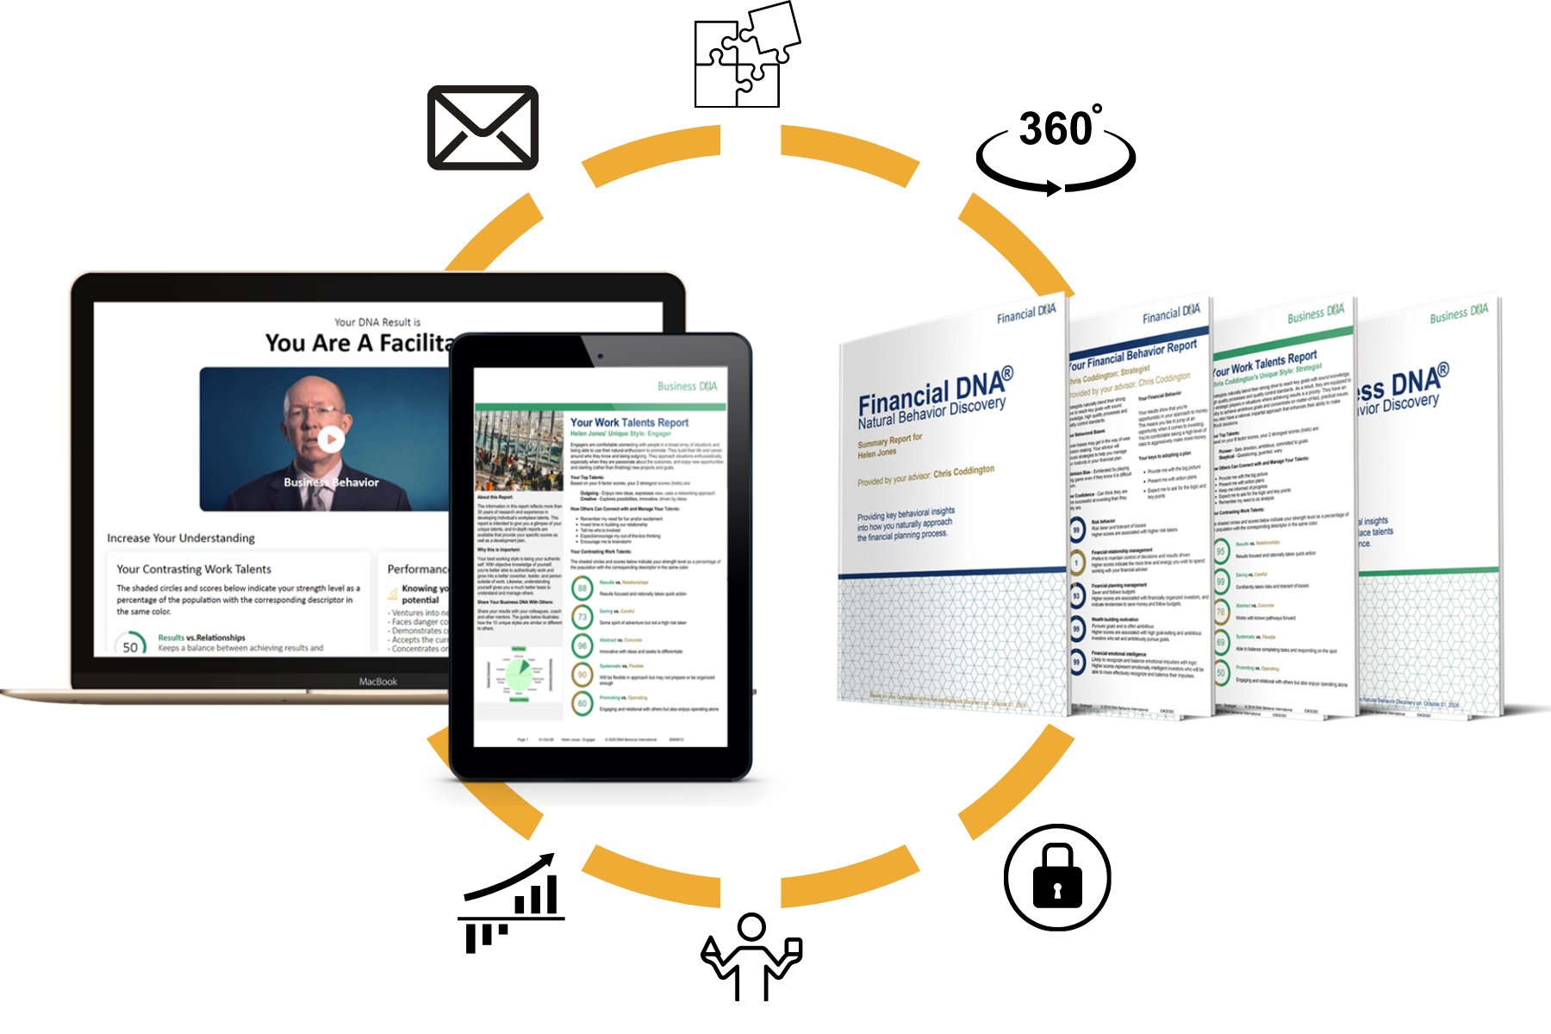
To learn more about DNA Behavior International and the solutions we offer, please visit: www.dnabehavior.com

If you have any questions or would like to discuss the DNA Hiring Performance Process with an executive on our team, please email us at: inquiries@dnabehavior.com

Appendix: Due Diligence for Hiring

None of these suggestions are intended to supersede existing human resources policies & procedures.
Standard methods to gain insights into an individual’s potential for success in a particular position.
- Résumé
- Completion of the DNA Natural Behavior Discovery process to uncover their “hardwired” strengths and struggles which can be predicted with 91% reliability to show up in the role , even if masked during the interview.
- Comparison of the candidate’s natural DNA behavioral style to role benchmarks
- Other types of cognitive testing as appropriate
- References
- Recommendations by people you don’t know
- Recommendations by people you do know or are known to someone you know
- Past work history
- Education and training patterns and results
- Achievements of the past
- Interview
- Interview by someone in the company of the opposite sex (and/or other demographics) from the primary interviewer (women and men often discern very different insights in an interview).
- Current life situation, such as willingness to relocate
- Expressed goals for the future
- Attitude and other intangibles
- Trial with a short-term project, contract, or temporary basis
- Production of work samples relevant to the role

*Note: Although we believe very strongly in using behavioral assessments to facilitate interviews and gain insights into potential employees, we caution that they should be used as only one of many sources of information for hiring decisions.
Some key factors to consider in the hiring process (these are not intended to be interview questions, but they can serve as a general guide to help you evaluate the potential match):
- Purpose and Passion
  - What does the person want to do?
  - How strong is the desire?
  - What are their motivating factors?

- Natural Talents (behavioral strengths, personality, temperament)
- How closely do the candidate’s natural DNA behavioral strengths (talents) and struggles match what is commonly found in those who succeed in this or similar positions?

These talents should be ones that the person is highly motivated to use. For instance, corporate trainers usually love to prepare and perform by presenting material to a group. A trainer who does not have a passion for communicating information to a group is likely to be a dull and unmotivated speaker.
- Character and Integrity
- Is this person reliable?
- Is this person ethical?
- Will they do the right thing under pressure or when presented with a conflict
- Is their work ethic compatible with the job, mission, and organization?

- Experience
- What type of work have they done in the past?
- How much of their experience will transfer into the position you are filling?
- What has been the level of achievement?
- Are you considering the candidate more for now or later?

- Job-related
- Has the candidate demonstrated the skills needed in the position based on past performance?

- Chemistry and Diversity
- How well will this person fit the work team?
- Can they quickly become part of the group?
- Is it likely that they will accept others on the team and be accepted by them?
- Caution! Don’t make the common mistake of seeing “different as wrong.” Diversity is essential to a competitive workplace. Also, remember that your past experiences can bias first impressions.

- Values
- Will your organization’s products, services, and culture be complementary to the values of the individual and vice versa?
- Will there be conflicts? If so, how significant are the potential conflicts?
- Can everyone on the team accept the conflicts and still be good teammates?

- Retention and Career Progression
- Consider how long you would like to keep this person in this position.
- Try to determine how long the candidate would want to stay in it. Evaluate in your mind how much growth potential the person has.
- How strongly is the candidate motivated toward career progression versus stability? Is this person looking for a stepping-stone or a long-term relationship?

https://www.manpowergroup.com/media-center/news-releases/global-talent-shortages-hit-record-high
Noise: A Flaw in Human Judgment by Cass R. Sunstein, Daniel Kahneman, and Olivier Sibony
https://www.eeoc.gov/laws/guidance/americans-disabilities-act-and-use-software-algorithms-and-artificial-intelligence
https://www.eeoc.gov/laws/guidance/background-checks-what-employers-need-know
https://www.leadershipiq.com/blogs/leadershipiq/the-worker-shortage-is-partially-self-inflicted

