A Guide to Correcting Predictions

Correcting Predictions

- On a real-time basis, knowledge can be increased as decisions are being made to make corrective predictions so that the decision-making process can be de-biased to improve judgments or tame the Bias before they affect judgments.
- Often, when making forecasts, there is a tendency to place an over-reliance on assumptions or a make leap in coming to a conclusion based on information with limited diagnostic value to the predicted situation. Also, past performance is not necessarily a predictor of future performance.
- The following is a statistical method to make a better judgment:
- Answer the question at hand with an intuitive guess.
- What is the mean answer based on an outside view of the situation (examining other outside data) if you knew nothing about the specifics of the situation or person involved – statistically, what would an average answer be?
- Estimate the diagnostic value of the information you have – what is the predictive value of the information you have to make the decision expressed as a correlation with the outcome you are predicting? Ultimately, this correlation has to be guessed. But, the correlations are likely to be in the range of 0.2 and can go up to 0.5 (but rarely).
- Then adjust from the mean answer (up or down) in 3(b) above in the direction of the intuitive guess in 3(a) above by the percentage in 3(c) applied to the gap between 3(b) and 3(a).
- This means that the corrected prediction will be more conservative than the intuitive ones. That is, the intuitive predictions will be more extreme away from the mean. So, corrected predictions do not take bets on outliers as there will be regression to the mean.

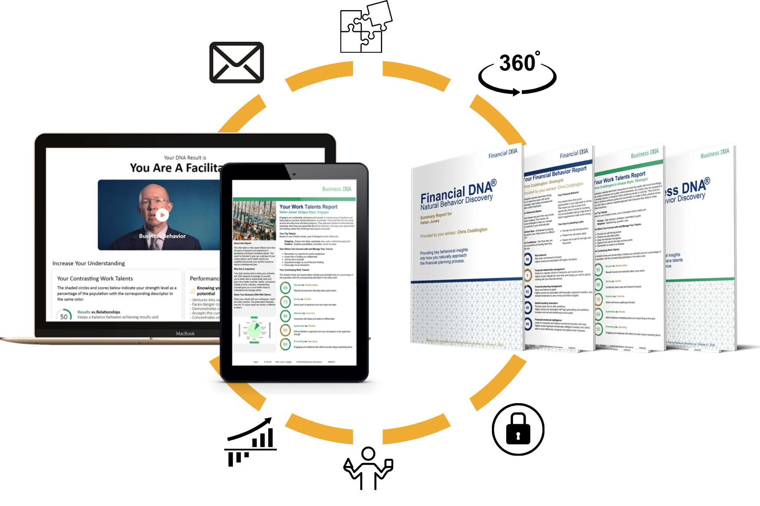
To learn more about DNA Behavior International and the solutions we offer, please visit: www.dnabehavior.com
If you have any questions or would like to discuss with an executive on our team, please email us at: inquiries@dnabehavior.com

